VAMSI 192011429

EXPERIMENT 5

Data Link Layer Traffic Simulation using Packet Tracer Analysis of ARP

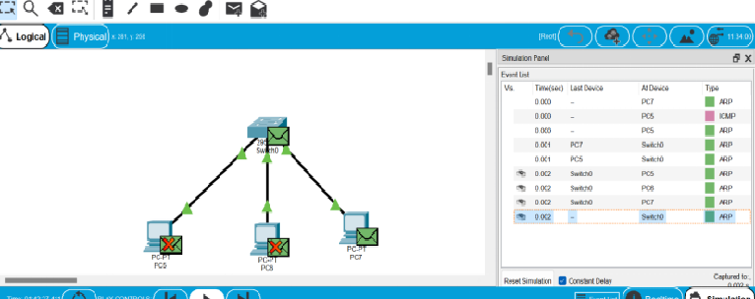

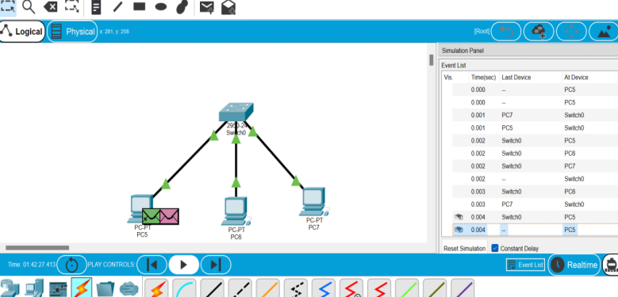

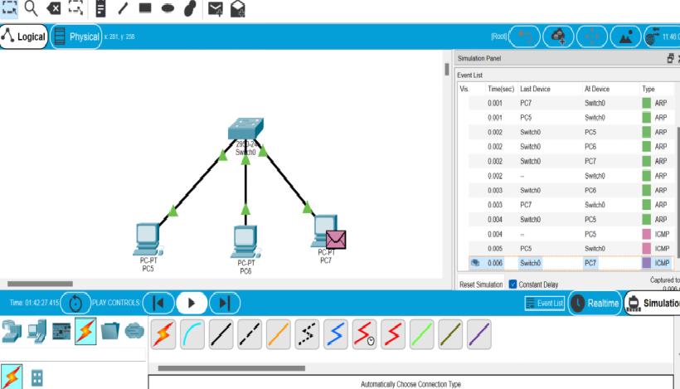

Result: we got the output as we excepted..